**HOW TO MAKE A FORMATTED CDF DEMONSTRATION**

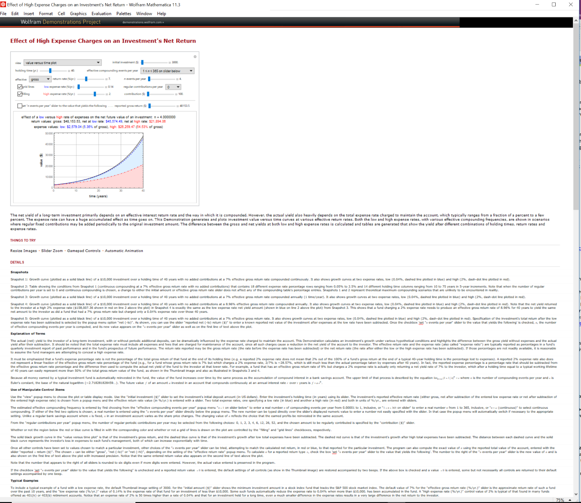So, you want to make a CDF file that looks like this:

But you only have a demonstration that looks like this, and you don't want to publish it publicly**:**

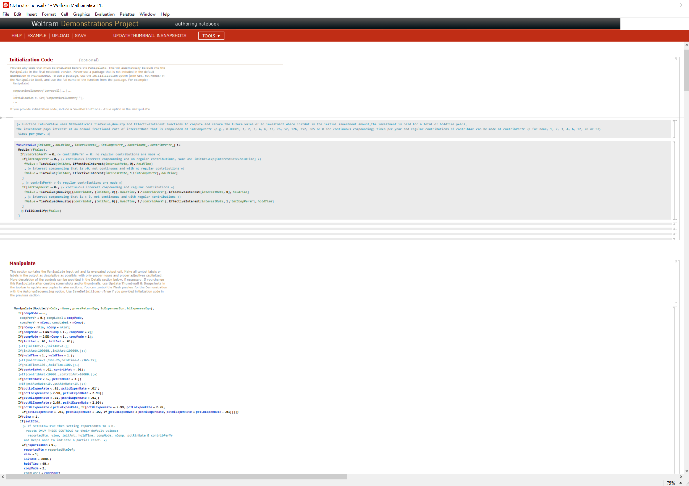

**You might notice that if you save this as a .CDF file, it doesn't automatically format this .nb file to look like the first picture ... Well there is a quick solution! Just follow these instructions.**

1. When you have finished making your demonstration and want to turn it into a formatted .CDF, first save the completed notebook as you normally would with any regular demonstration:

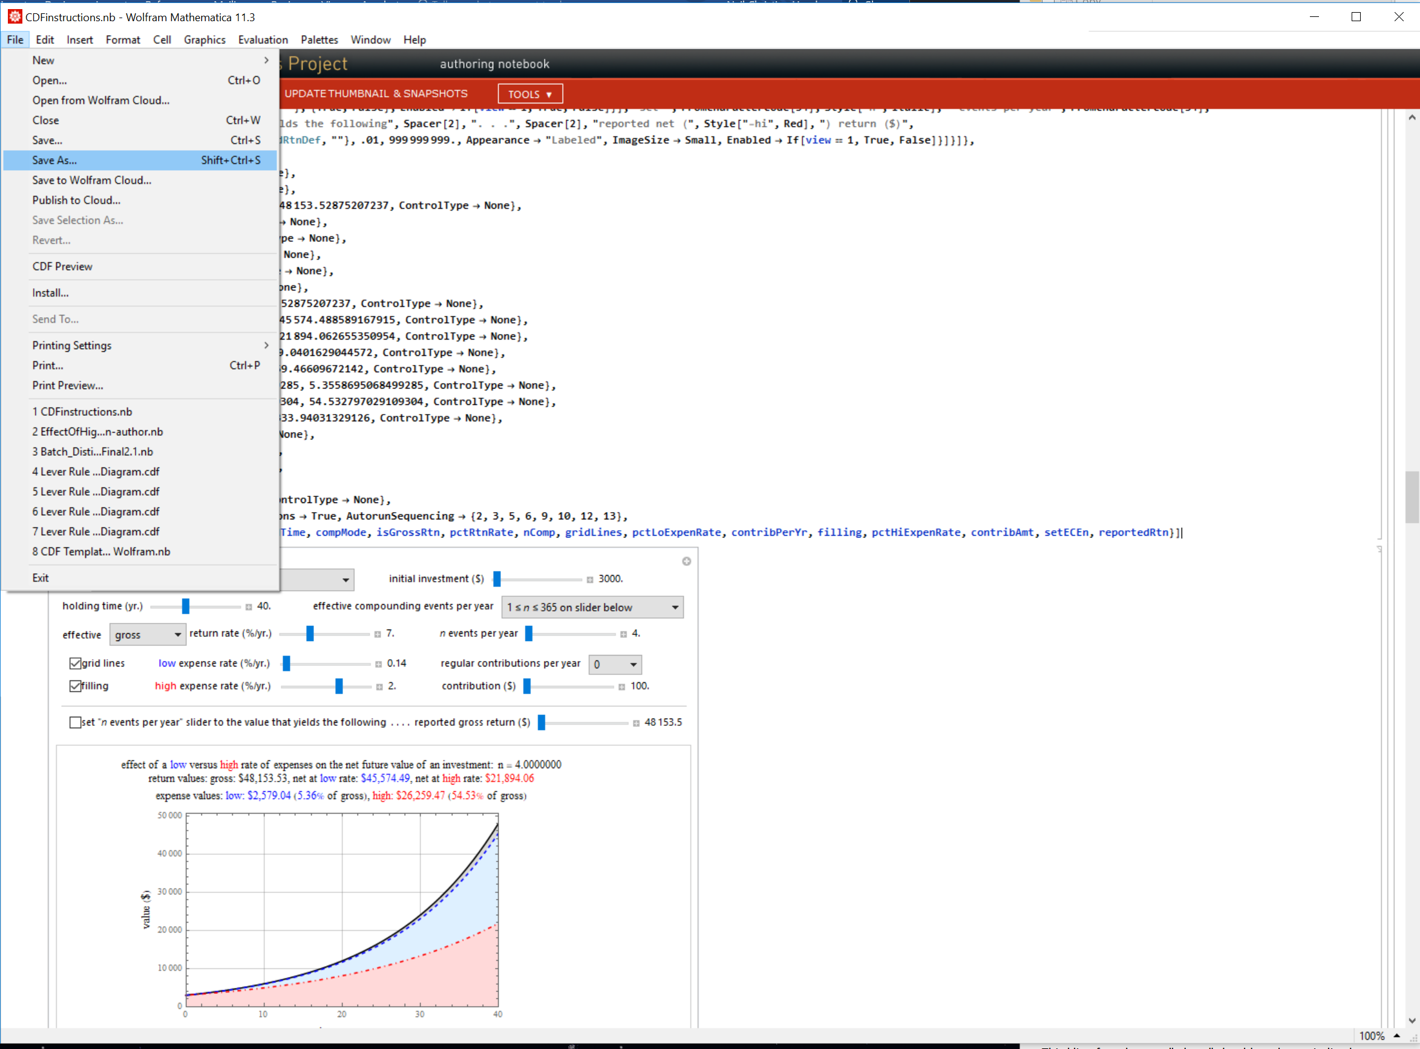

2. Next, go to the Wolfram Demonstrations website, find the authoring area and sign in:

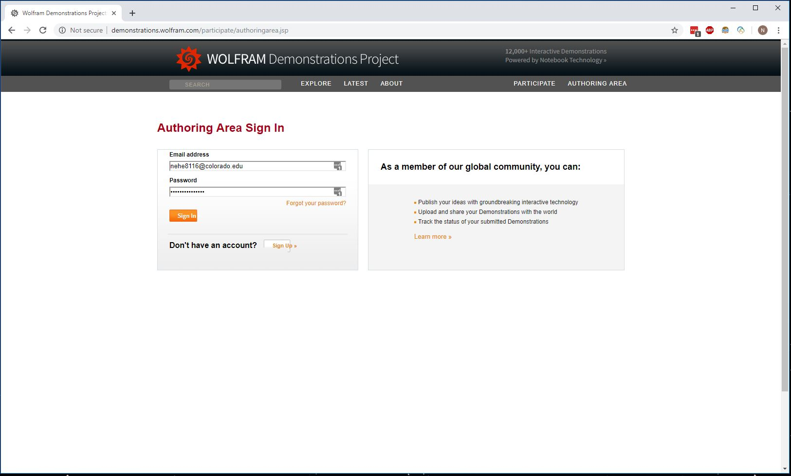

3. Once you have signed in, upload your demonstration the same way you would if you were going to submit it for publication on the website (don't worry, we won't be submitting it to Wolfram to publish):

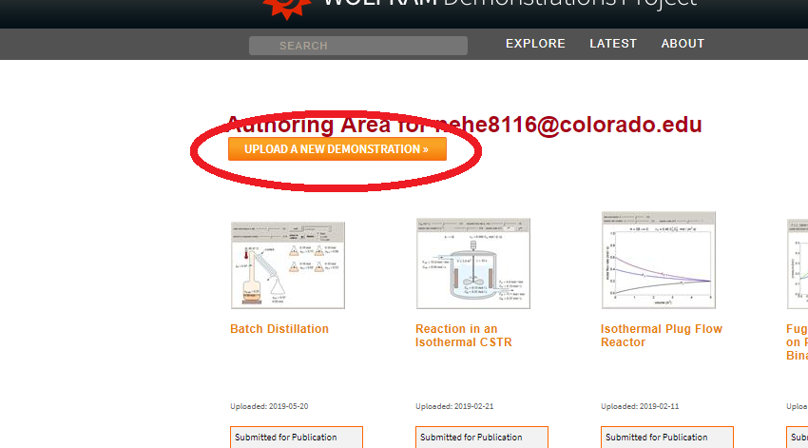

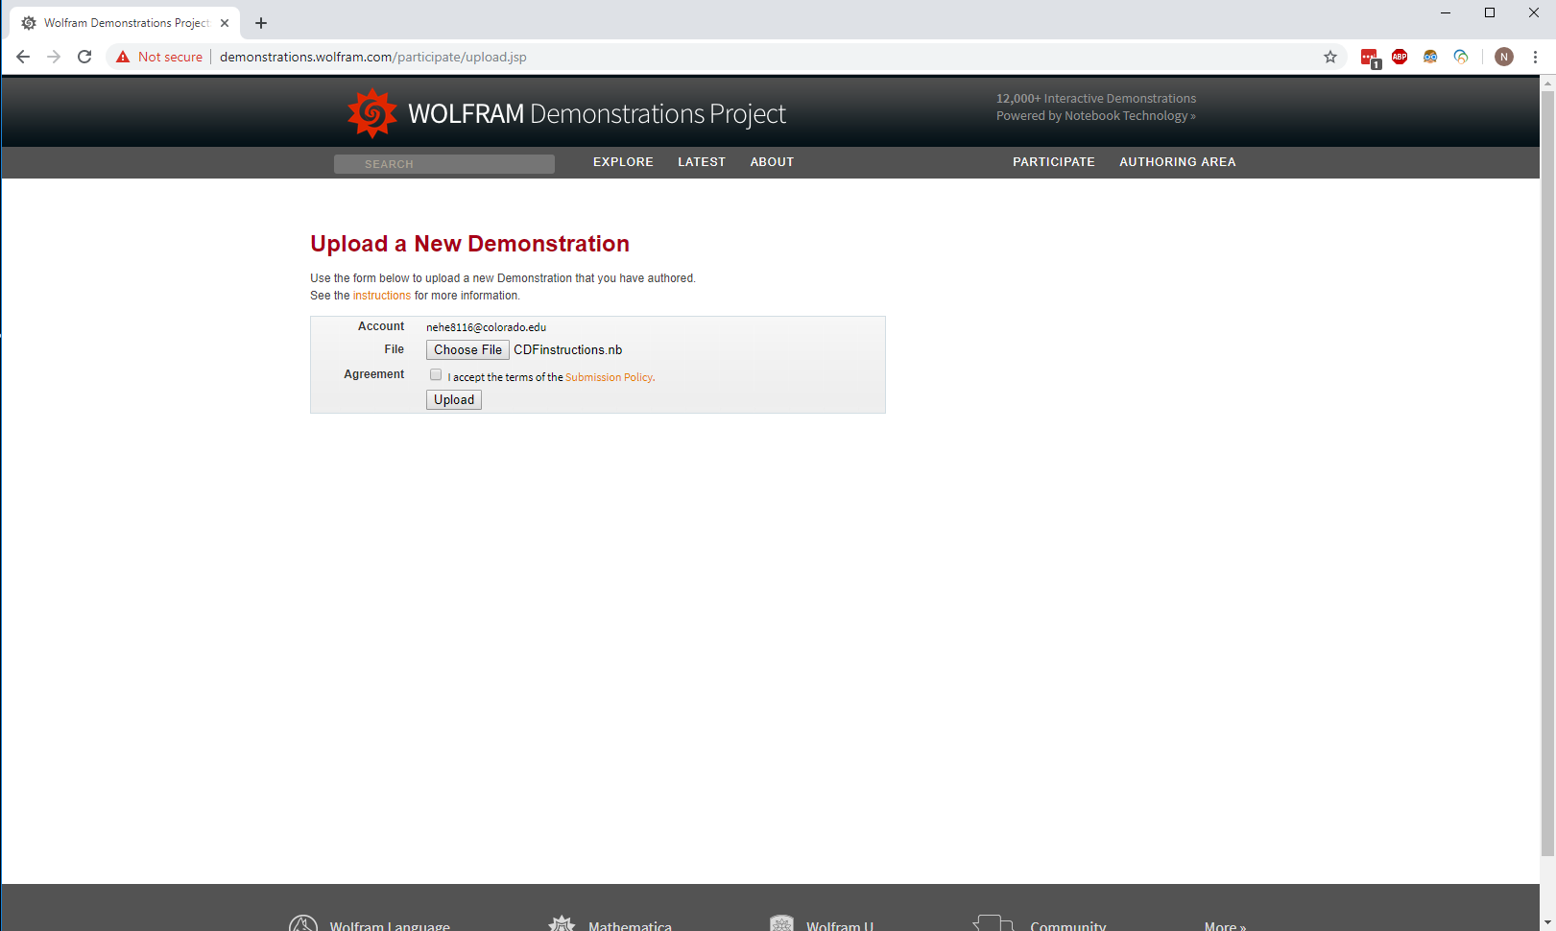You should see this screen. Click "I accept the terms.." and hit "upload".

4. Your demonstration will be formatted and upload to your authoring area. After a minute or two, this window should appear:

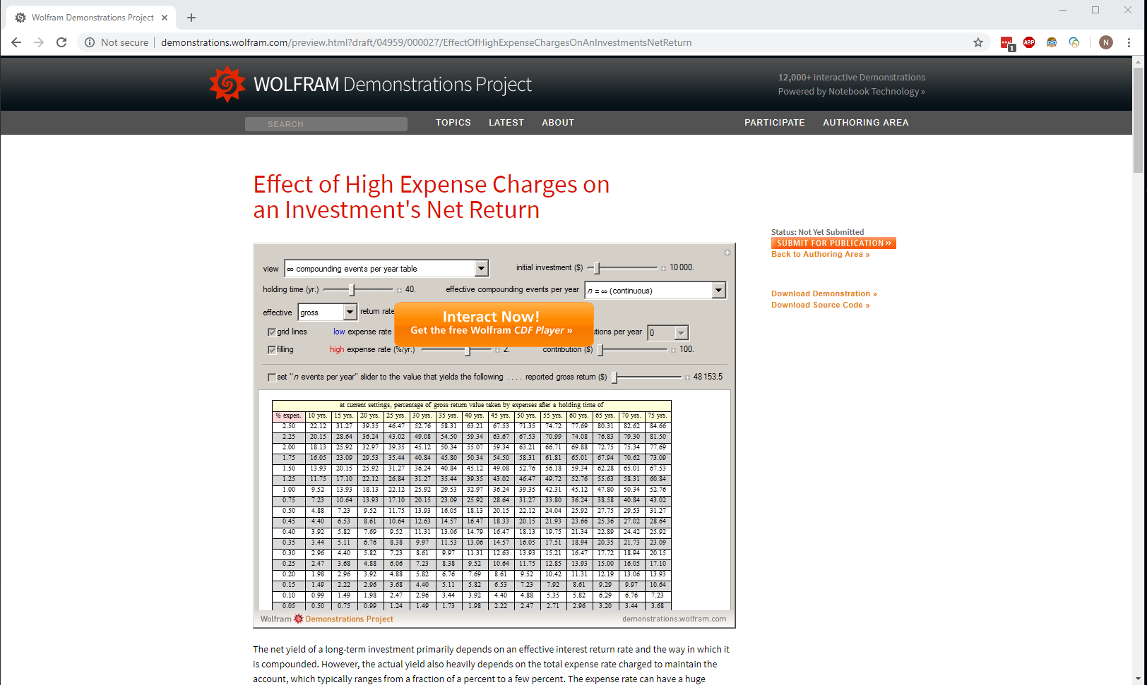

5. On the right side of the screen, press "Download Demonstration", and you'll have your formatted .CDF file!

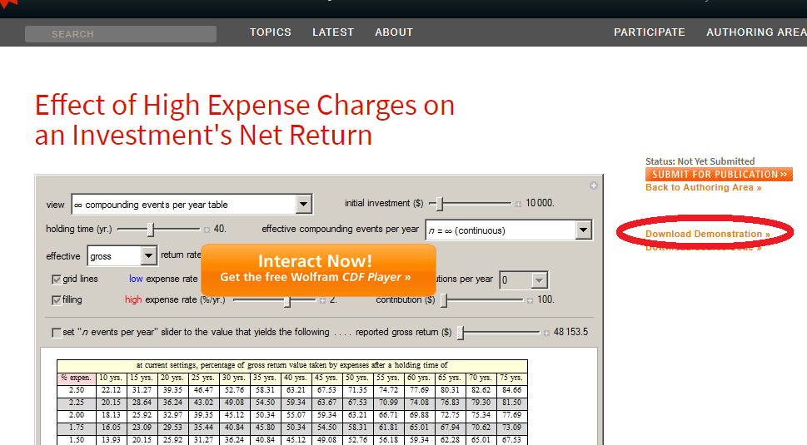

6. Finally, press "Back to Authoring Area", and remove your demonstration from your authoring area.

7. Celebrate!